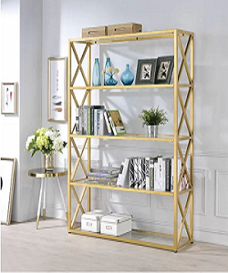

Bookcase

$163.39

Availability: In stock

Description:

The real modular extruded aluminum bookcase, a special way to personalize your space. It’s a system that can be used everywhere: in office, in living room, and in a book store of a winebar.This furniture is usable for every need. The real modular extruded wood bookcase,a special way to personalize your space.It's a system that can be used everywhere: in office, in living room,and in a book store of a winebar.This furniture is usable for every need.